Student’s name | …………………………………………………….…… | Grade | 4
Subject | Computer | Quiz No. | 1
Quiz No. ( 1 )

10
write the correct name of each part.

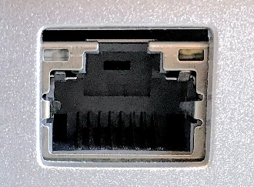
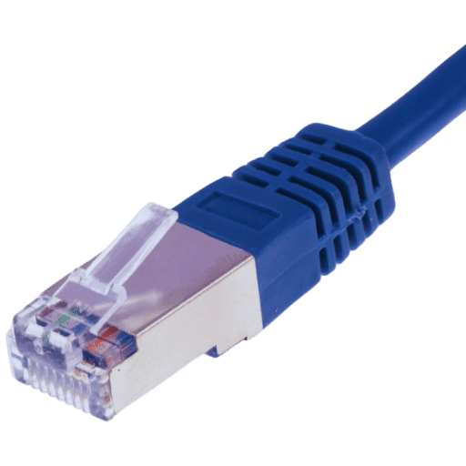
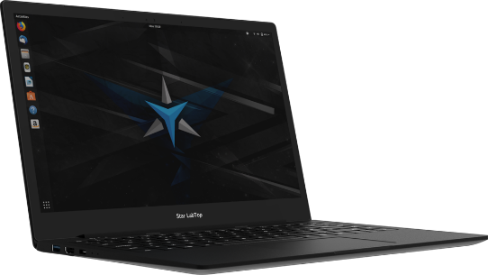
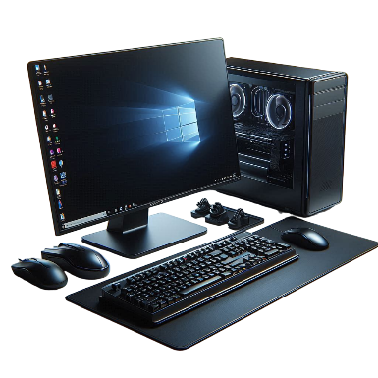
Good Luck

Ethernet Cable
Laptop
Ethernet Port
CPU
Vector

